SELECT * FROM obat ORDER BY nama_obat DESC;

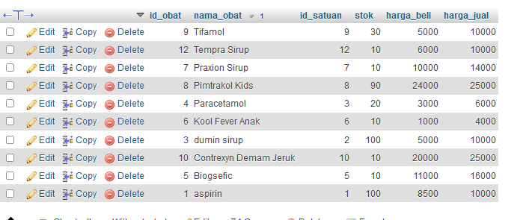

SELECT * FROM obat ORDER BY stok ASC;

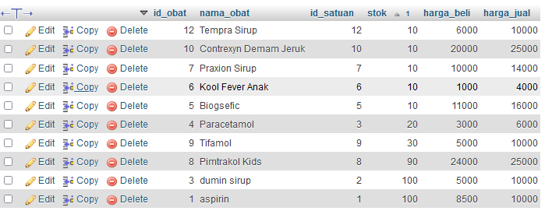

SELECT * FROM obat WHERE stok LIKE '%100'

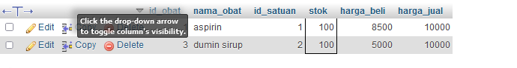

SELECT * FROM obat WHERE nama_obat LIKE 'paracetamol'

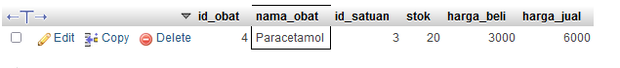

SELECT id_obat, SUM(stok) as harga_jual FROM obat GROUP by id_obat;

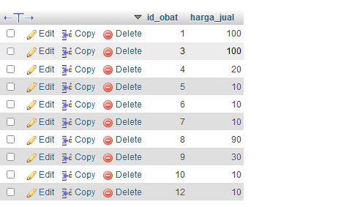

SELECT * FROM obat WHERE NOT stok = 0;

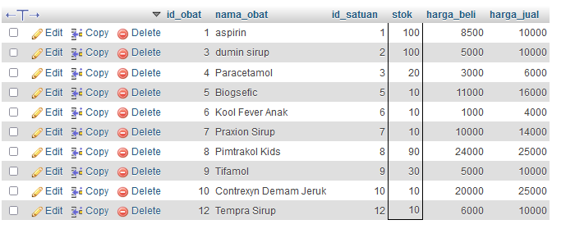

SELECT id_obat, SUM(stok) as harga_jual FROM obat

GROUP by id_obat;

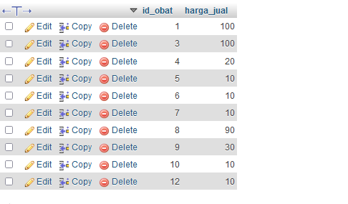

SELECT harga_jual, SUM(stok) as stok FROM obat

GROUP by harga_jual;

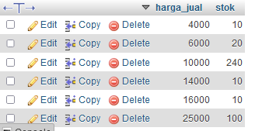

SELECT harga_beli, SUM(stok) as harga_jual FROM obat

GROUP by harga_beli;

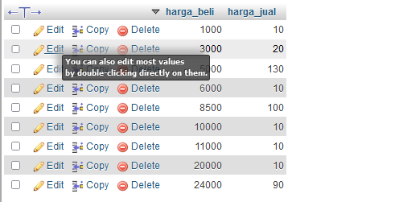

SELECT nama_obat, SUM(stok) as harga_jual FROM obat

GROUP by nama_obat ORDER by nama_obat DESC;

